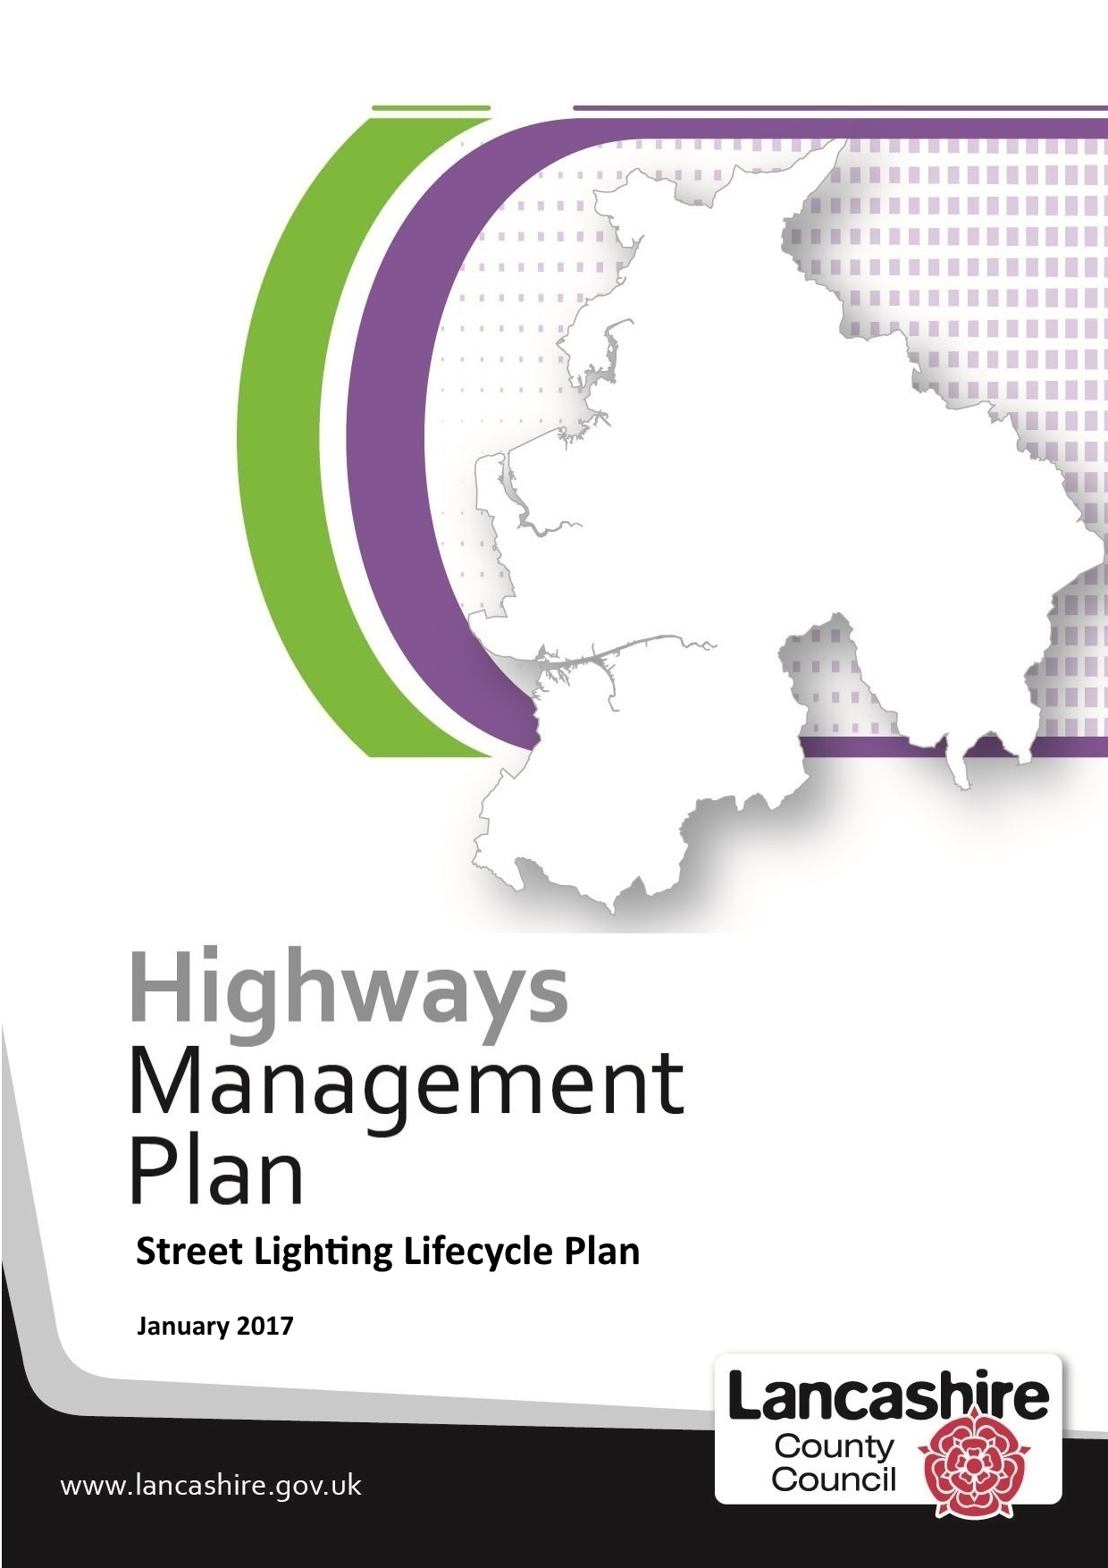
Carriageway Lifecycle Plan
Version | Date | Author | Changes
0.1 | 26/01/2017 | Yotta Ltd. (JC) | Initial draft
0.2 | Jan 2017 | Yotta Ltd. (JC) | Update
0.3 | Jan 2017 | KP | Update to Sections 5, 6, 7
0.4 | Feb 17 | PB | For Strategy Board Comment

Chapter | Description | Page
1 | Introduction | 4
2 | Context of the Carriageway Lifecycle Plan | 6
3 | Customer Aspirations | 8
4 | Carriageway Lifecycle Modelling | 9
5 | Whole Life Costs Approach | 13
6 | Asset Performance | 15
7 | Forward Years Works Programme | 19
8 | Risk Management | 20
9 | Future Changes & Improvement Plan | 21
Appendix A | Carriageway condition modelling and treatment option selection
Appendix B | Carriageway Inspection Standards

1 – Introduction

The Highways Asset Management Framework, adopted in December 2016, is the overarching document that provides a framework for highway asset management in Lancashire. It clearly sets out what highway asset management means to us and outlines the procedures, processes and systems we have, or intend to put in place, to help us ensure that our highway and transport assets are maintained in a condition that is considered fit and safe for reasonable use.

Lifecycle planning is an important aspect of asset management and involves drawing up long-term plans for managing an asset grouping with the aim of providing the required levels of service at the lowest whole life cost.

Lifecycle plans capture all information relating to the inventory, its condition and performance. They also identify both the short-term routine maintenance needs and long-term capital costs and enable annual spend profiles per asset to be produced. They also enable long-term predictions about the deterioration of various assets and their maintenance needs to be forecast.

Lifecycle plans also provide secondary benefits in enabling the 'institutional knowledge' i.e. the knowledge and judgement of key personnel, to be captured and documented, thereby enabling it to be shared and further developed. They also enable the County Council to gather information on the costs for each treatment option and the effect that this expenditure has on performance improvement year on year. Once these are known benchmarking can then take place with other authorities / treatments etc.

Lifecycle Planning recognises that there are key stages in the life of each asset type and that investment options need to be considered at each of these stages to ensure that each part of the asset achieves its full expected life, at minimum cost. Each asset goes through the following stages during its lifecycle:

Creation or Acquisition | Assets are created or acquired in response to either new development, to increase capacity or to improve performance.
Routine Maintenance | Carrying out minor works on a cyclical basis to maintain the asset in a serviceable condition.
Renewal or Replacement | Carrying out to return the asset to its "as new" capacity and condition.
Upgrading | Improve the asset above its original standard.
Disposal | Involves decommissioning, demolishing or selling old, obsolete or surplus assets.

This document describes the outline approach to carriageway lifecycle planning to ensure that the carriageway asset is effectively and efficiently maintained in accordance with the objectives set the Highway Asset Management Framework.

The next update is scheduled for August 2018 which will take into account the requirements of 'Well-managed Highway Infrastructure Code of Practice' which was released by the UK Roads Liaison Group in October 2016, and will reflect national changes in working practices, technology, legislation and guidance.

The document covers:
- The context of the lifecycle plan
- A description of lifecycle modelling approach
- The use of lifecycle planning in whole life costing
- Use of lifecycle planning in determining progress towards meeting TAMP Service Standards
- Future years work programmes
- Management of risk
- Changes and improvements

2) Context of the Carriageway Lifecycle Plan:

Context:

The Highways Asset Management Framework sets the overall context for the management of the Highways Asset. Within the Framework the Transport Asset Management Plan (TAMP) identifies the key strategic priorities of Lancashire County Council, as the highway authority for Lancashire, during the period 2015/16 to 2029/30.

The objective of the TAMP is to reduce key maintenance backlogs over a period of ten to fifteen years through the adoption of a more preventative approach to maintenance which will lead to a reduction in the annual investment required to maintain our assets in an improved condition.

The strategy is based on managing our assets on a holistic basis and recognises that as we cannot do everything all at once, we need to prioritise between our assets based on the relative importance that each asset group contributes towards our goal of delivering an effective transport system and achieve our broader economic, social and environmental goals

In order that we can meet these goals we have developed a 15-year plan that is comprised of three discrete 5 year phases. In line with this significant investment into the A, B and C road network is taking place between April 2015 and March 2020. From 1st April 2020 until March 2026, the focus will then shift to the rural unclassified and urban unclassified road networks.

Carriageway Lifecycle planning supports this approach by:

- using preventative treatments at the optimum times to reduce whole life costs
- resurfacing the carriageway at the optimum time to reduce whole life costs
- using the correct materials for carriageway and footway
- providing appropriate Skid Resistance to the carriageway,
- delivering carriageway maintenance sustainably, economically and effectively.

Carriageway Lengths in Lancashire

In Lancashire there are approximately 7032 Km of carriageway maintained by the County Council.
A, B and C Roads | 2,567 | Km
Rural Unclassified Roads | 1,065 | Km
Residential Unclassified Roads | 3,400 | Km
Moss Roads | 400 | Km | (approx.)

Highway (Carriageway) Codes of Practice and Guidance

The carriageway lifecycle plan recognises that the authority has the duty of maintenance for highways maintainable at public expense as contained in the Highways Act 1980 Section 41 and the recommendations contained within various codes of practice, procedures and standards which include:

- UKRLG Well Maintained Highways Code of Practice*
- HMEP UKRLG Highway Infrastructure Asset Management Guidance
- Manual for Streets
- Design Manual for Roads and Bridges (Volume 7)
- HMEP Pothole Review

Lancashire has initiated an implementation programme to address the requirements of the new code and fully implement a risk-based approach by October 2018.

3 – Customer Aspirations

It is important that the county council actively seeks the views of its customers and residents in order that it can understand their needs and adapt its services accordingly. Traditionally the county council has used the Living in Lancashire surveys to receive feedback.

The latest LIL Survey results can be found on the Highway Asset Management webpage
http://www.lancashire.gov.uk/council/strategies-policies-plans/roads-parking-and-travel/highway-asset-management-in-lancashire.asp
These results are considered by the Highway Infrastructure Strategy Board and used, along with other benchmarking information, to inform service delivery options.

The results of the Living in Lancashire surveys will from April 2016 be supplemented by the views of those residents affected by highway capital works. Prior to the commencement of each scheme the County Council will conduct a 'letter drop' to all residents and businesses effected by the works. In addition to notifying of the works the letter will inviting feedback either via the internet or by phoning the Customer Service Centre. The Online Survey is available at www.lancashire.gov.uk/roadsurvey

The results of the above surveys are analysed the results considered as part of service development bring about continuous improvement. The results of the surveys will also be complied into and published in the form of the annual report and used in future years to help us improve the service we provide.

From 2017 the county council will be subscribing to the National Highways & Transport Network survey which will enable us to compare and benchmark our performance nationally against other authorities.

4 – Carriageway Lifecycle Modelling

Asset Lifecycle
The following describes the stages in an assets life cycle that underpin the lifecycle modelling

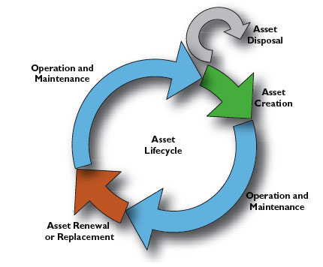

Asset Creation (Construction / Asset Acquisition)
New assets are typically acquired from either adoption or from taking over improvement works completed by contractors on behalf of the council. This is normally managed by the development control team using Section 38, 278 or 106 legal agreements.

Newly constructed 'adoptable' streets are only adopted and added to Lancashire’s Asset Register once they meet council specifications.

Operation and Maintenance (incl. Routine Maintenance)
Routine maintenance treatments are undertaken to ensure the carriageway asset is maintained at a minimum service level. Safety inspectors are responsible for identifying and assessing any defects which reduce the safety of the road user.

Investigatory Levels are the point when a risk assessment should be conducted. Lancashire’s Highway Safety Inspection Code of Practice provides a list of investigatory levels for the main defects and details Carriageway Investigatory Levels.

Asset Renewal
Treatments for the renewal of the carriageway and footway are outlined in the Transport and Asset Management Plan. The national guidance has been adopted to steer away from treating the worst first locations and focuses on preventing the strategic network from deterioration. The maintenance treatments used on the network are a combination of preventative maintenance and resurfacing works. Surface treatments such as surface dressing is applied at the optimum time to prolong the life of the carriageway and reduce the rate of deterioration. Resurfacing of the carriageway is undertaken at the optimum time to prevent further more costly reconstruction works.

The choice of treatment for the carriageway and footway is identified from the condition data, and deterioration modelling of the network by using a carriageway life cycle toolkit. The results from the model are used to justify investment decisions and enable a reduction in whole life costs. A three year preventative and resurfacing programme for all classification of highway has been identified to enable programming of the works at the optimum time.

A new revised network hierarchy is being developed based on risk, in accordance with the recently released National guidance 'Well Managed Highways'. Preventative and resurfacing treatments on this network will be made priority.

Lifecycle Modelling

The following describes the lifecycle modelling approach currently used in Lancashire. The objectives of lifecycle planning are stated by the UK Roads Liaison Group in the Highway Infrastructure Asset Management Guidance as:

- Identify long term investment for highway infrastructure assets and develop an appropriate maintenance strategy.

- Support decision making, the case for investing in maintenance activities and demonstrate the impact of different funding scenarios.

- Predict future performance of highway infrastructure assets for different levels of investment and different maintenance strategies.

To address these objectives we have established a lifecycle planning process aligned the recommendations of the guidance. It has implemented a rolling programme of lifecycle review and maintenance based on the principles of minimised whole life cost.

A carriageway asset lifecycle model, calibrated to local condition and priorities, has been established. The model enables the authority to examine the effect of different maintenance, performance and investment scenarios. Outline scenarios aligned to the recommendations of the Highway Infrastructure Asset Management Guidance have been developed.

- Determine the level of investment required to achieve the required performance.
- Determine the performance that will be achieved for available funding and/or future investment.
- Minimising costs over the lifecycle while maintaining the required performance.

The lifecycle planning approach targets the delivery of agreed levels of performance at 5, 10 and 15 year milestones in accordance with the established TAMP Service Standards.
Lancashire has implemented a lifecycle planning process, enabling determination of the most appropriate maintenance and investment strategies to support the achievement of the authority’s goals and objectives for the highway maintenance.

In developing the lifecycle plan, a balanced scorecard approach has been adopted, aligning highway maintenance decision making to departmental and council priorities.

We currently uses various software programmes to assist it with lifecycle planning. The proprietary software enables condition data to be imported into data modelling software which can then be used to predict and optimise maintenance requirements for Lancashire's carriageways.

Modelling and lifecycle tools will enable us to evaluate, using graphical outputs and reports, the long term effects of a particular funding scenarios. The software will also enable long-term maintenance scenarios to be produced which detail the optimal treatment and associated cost to support whole of life management of the highways asset and enable us to fully evaluate the maintenance backlog across the whole of Lancashire's highway network.

Details of the carriageway condition modelling and treatment option selection can be found in Appendix A

Lifecycle planning for the A, B, C network is refreshed on a yearly basis. The historic data from the annual SCANNER surveys allows deterioration modelling of the classified network. Long term plans of the classified network for investment have been undertaken which has created a 3 year planning of maintenance schemes. A full condition data set for the unclassified and footway network is now available, this will be used to model the unclassified network and allow long term planning. This will be available from 2017.

Evidence arising from lifecycle modelling activity is used to demonstrate how funding and / or performance requirements are achieved by implementation of maintenance strategies with the objective of minimising expenditure, while providing the required performance over a specified period of time.

When developing options, consideration needs to be given to the desired future performance of the asset, together with best practice guidance, legal and statutory requirements, County Council strategic priorities and objectives, customer expectations, engineering judgement, risk and financial considerations and new innovations.

Highway Safety Inspections

The routine safety inspections, which are in place in Lancashire, allow us to regularly monitor the vehicular highway network for dangerous defects. They consist of a systematic inspection of the adopted vehicular highway network in order to identify and rectify any defects that represent a danger to the public in terms of either personal injury, or damage to vehicles and/or personal property. The frequency of inspection and response to defects varies with the relative importance of each section of highway and this has been determined with due regard to the guidance provided in the national Code of Practice for Maintenance Management (July 2001) and the Code of Practice for Maintenance Management - ‘Well-maintained Highways’ (2005)

The overall objective of safety inspections is to make the highway safer for users. This will inevitably reduce the number of people injured due to falls etc. It should also reduce the number and overall cost of claims made against the County Council as Highway Authority

Appendix B details the Carriageway Inspection Standards

5) Whole Life Cost Approach

Central to the Lifecycle Planning approach is the use of Whole Life Costs (WLC), which seeks to determine the total cost of ownership of an asset. It involves a structured approach to identify the direct and indirect costs that may occur during its lifecycle. It provides a basis for comparing alternative maintenance strategies in order to identify the most advantageous option over a defined period.

A whole life cost approach ensures that consideration is given to the maintenance requirements throughout the asset’s lifecycle. Alternative maintenance strategies can be evaluated in terms of future cost and asset performance.

Whole life costing for maintenance strategy option appraisal ensures that the most beneficial treatments are applied at the most opportune time, enabling informed maintenance planning decisions to be made, to maximise cost benefit and value.

At scheme level, whole life costing may be used as one of the criteria upon which maintenance decisions are made and the preferred option selected. However, it is not the only factor, other factors such as engineering judgement, network operations, buildability, affordability and risk management also require consideration.

Well Managed Highway Infrastructure Code of Practice describes how whole life costing may be incorporated into a value management process that considers a range of issues and influences to be considered during the development of a prioritised programme of schemes that is aligned with Lancashire’s objectives and which delivers value for money.

Practical Implementation of Whole Life Cost approaches

Lancashire’s current asset management model identifies discrete treatments addressing local priorities and delivering the greatest value (measured as cost benefit) across the carriageway network.

The modelling outputs identifies maintenance treatments required at the optimum time period using the parameters set within the model. The Asset Management and Engineering teams review and validate these treatments proposed by network level cost benefit analysis. This supports them to develop the results into practically deliverable schemes of work at a local level for the given section of carriageway. The specification, location and extent of each differing in each year, giving the financial implications of not undertaking the treatments at the optimum time. This enables the development of the annual capital programme through the local value management process.

When validating outputs of the analysis process, the Authorities Asset team evaluate proposed treatments with regard to the recommended timing of intervention, extent and specification.

The introduction of HAMS (Highways Asset Management System)

The Authorities Core Systems Transformation Programme is implementing a major service review of the way that Lancashire currently manages the highway and property assets. This includes moving away from currently disjointed systems to enable a one system approach, which supports the on-going, major business transformation programme being carried out by the county council. This is due to be implemented in 2017 and will underpin the smooth delivery of the county council's Financial Strategy.

A key part of the transformation will be the use of technology based around the principle of an integrated, customer focused solution which supports mobile working and end to end business processes. The programme will deliver a Highway Asset Management System (HAMS).This will provide an integrated solution that will handle and monitor all the highway and asset management processes.

The Highways Asset Management team will work to integrate the life cycle planning approach developed for carriageways and the HAMS system.

6) Asset Performance

This section describes how the Lifecycle Modelling is used to manage the performance of the carriageway asset to ensure delivery of the Service Standards set in the TAMP

The overall condition of the transport infrastructure asset has been determined by assigning scores to each service standard. A weighted score has been produced by multiplying each score by the asset valuation.

These service standards have been used to determine and then model the desired future performance of the carriageway asset such that investment and maintenance decision making supports achievement of the targeted asset condition and the service standard.

The service standard targeted for A, B and C carriageway asset groups as described in TAMP Refresh June 2016 is outlined below for Phase One of the investment period to 2019/20.

Phase One 2015/16 to 2019/20 Highest Priority Areas
Asset  Category | 2014  Condition & Backlog | 15/16 to 19/20  Investment | Anticipated 19/20  Condition & Backlog
A, B & C  Roads | Condition:  overall ACCEPTABLE  Backlog:  1,059km RED or AMBER at the 25-40-50 standard  (A roads 25%, B roads 40% and C roads 50%) | £8m per year | Condition:  overall GOOD  Backlog:  Reduced by at least 85% and down to 150km RED or AMBER at the 10-15-20 standard  (A roads 10%, B roads 15% and C roads 20%)

Achievement of the service standard targeted by 2019/20 has been modelled based upon the current condition of the asset, anticipated deterioration and the treatments and priorities identified by the authority.

For the purposes of asset modelling, a linear performance target profile has been established for each road classification and the profile for each built into the asset.

Lancashire’s desired performance is detailed in the TAMP Service Standards.

Current asset performance is assessed by collecting information, based on the survey and data collection approach described in this document and using national and local performance measures to monitor performance change over time. The performance gap is reported through Lancashire’s performance management framework.

Performance targets have been determined for each classified road asset group. Different performance strategies have been adopted for each road classification. These are described below:

A Roads | B Roads | C Roads
Performance Strategy:  Targeted reduction in network Principal / A road indicator  (SDLI130-01) at red or amber to deliver TAMP Service Standard reductions by 2019/20.  Performance steady state maintained in line with  10 and 15-year carriageway asset performance targets.  2017 2018 2019  21.80% 15.90% 10.00% | Performance Strategy:  Targeted reduction in network Non-Principal / B road indicator  (SDLI130-02) at red or amber to deliver TAMP Service Standard reductions by 2019/20.  Performance steady state maintained in line with  10 and 15-year carriageway asset performance targets.  2017 2018% 2019  24.70% 19.85% 15.00% | Performance Strategy:  Targeted reduction in network Non-Principal / C road indicator  (SDLI130-02) at red or amber to deliver TAMP Service Standard reductions by 2019/20.  Performance steady state maintained in line with  10 and 15-year carriageway asset performance targets.  2017 2018 2019  34.50% 27.25% 20.00%

Addressing the performance gap
The carriageway asset management model has been used to run a multi-year performance scenario to identify the maintenance and investment requirement to meet the Service Standard targets at 5, 10 and 15 year milestones.

Using algorithmic analysis, the model targets the performance of the asset for the following performance indicators:

- Data Topic 130-01 – Principal roads where maintenance should be considered
- Data Topic 130-02 – Non-principal classified roads where maintenance should be considered

The130-02 performance indicator monitors performance for all non-principal roads, that including B and C roads. To align carriageway condition performance monitoring for Lancashire's network to the approach required by the Service Standard, bespoke performance monitors have been created. The monitor both the Red and the Amber condition bandings and enable performance for the B and C roads to be targeted separately.

The condition of the A, B and C road network is determined each year via the use of SCANNER surveys which are carried out by vehicles travelling at normal traffic speed that collect information relating to different parameters of the road. All measurements are recorded and loaded into a software programme which calculates an overall Road Condition Index (RCI) for each 10 metre subsection. The RCI is then used to classify a section of road as being RED, AMBER or GREEN.

A GREEN classification indicates those lengths of carriageway which are generally in a good state of repair. An AMBER classification indicates those lengths of carriageway where some deterioration is apparent and needs to be investigated at an early opportunity so as to determine the optimum time for planned maintenance. A RED classification indicates lengths of road which are in poor overall condition and are likely to require planned maintenance soon. As RED/AMBER sections of road require some sort of remedial works these form our maintenance backlog.

The figures below shows changes in the current and predicted levels of backlog on the ABC road network.

A Roads
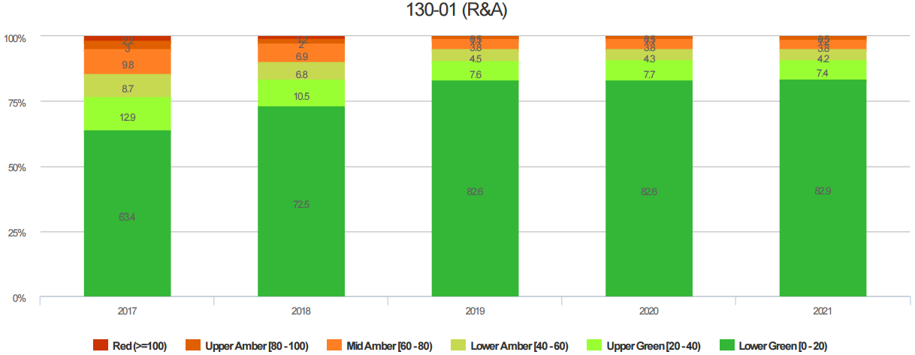

B Roads
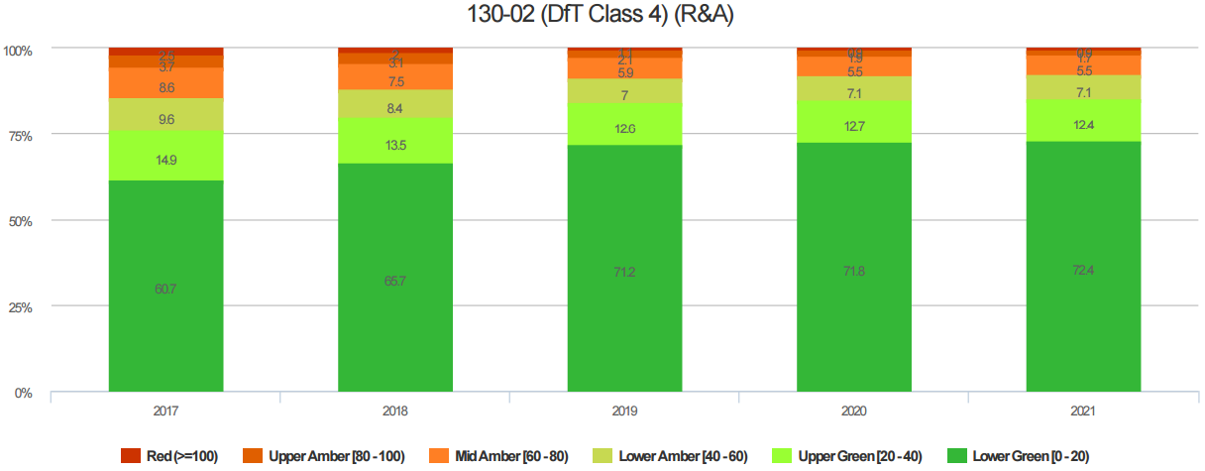

C Roads
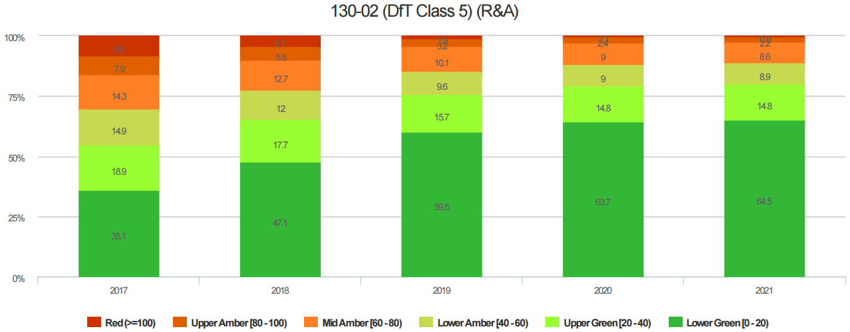

7) Forward Years Works Programme

Existing maintenance programme

The current approved capital programme for 2016/17 are available to view online through the following link:

http://www.lancashire.gov.uk/council/strategies-policies-plans/roads-parking-and-travel/highway-asset-management-in-lancashire/programme-of-works.aspx
2017/18 Capital Programme is due for approval in March and will be available to view at the above link.

A 3 year maintenance programme for the carriageway and footways has been developed as part of the life cycle planning through data analysis. It is subdivided into the following categories:

- ABC Surface Dressing
- ABC Resurfacing
- Urban unclassified (Residential)
- Rural unclassified
- Footways

This Programme of works is due to be approved in April and will be available to view on the above link.

8 – Risk Management

Risk Management is an important part of both corporate governance and performance management. It allows the Council to avoid problems and failures, rather than just reacting to them when they arise. It helps the Council to identify where it needs to focus its efforts and resources, to exploit more opportunities and suffer fewer failures. As part of the risk management process in the Council, these risks and opportunities are formalised and recorded.

The Highways Asset Management Framework details the approach to Risk for Highways assets

The risks associated with maintaining the asset at each of the defined service standards, including identification of risks associated with not maintaining to the desired standard are being developed and will be presented to the Highway Infrastructure Asset Management Strategy Board in April 2017

9 – Future Changes & Improvement Plan

The future approach is to undertake more preventative maintenance treatments on carriageways in the amber condition band. This will reduce the whole life cost of the carriageways as we will be eliminating lengths which would otherwise have deteriorated to a red condition requiring more expensive treatments to remain in service.

the performance of implemented carriageway programmes of work and using performance information arising to inform treatment calibration within the model will be monitored and help support the development of future approach.

Ref: | Action | Timescale | Responsibility
CWLCP 1 | Develop 5, 10 and 15 year scenarios to inform predicted performance outcomes and investment decision making. | By July 2017 | Highway Asset Management Principal
CWLCP 2 | Develop a needs based programme and budget approach using asset data to inform budget requirements and treatment spend. | By July 2017 | Highway Asset Management Principal
CWLCP 3 | Calibrate the carriageway asset management model to support asset valuation and maintenance backlog calculation. | By July 2017 | Highway Asset Management Principal
CWLCP 4 | Identify future management strategies and update the LCP accordingly. | By October 2018 | Highway Asset Management Principal
CWLCP 5 | Develop a maintenance hierarchy based on the resilient network | By October 2017 | Highway Asset Manager
CWLCP 6 | Review and update the Highway Maintenance Plan | By January 2018 | Highway Asset Management Policy Officer
CWLCP 7 | Develop a long term strategy for urban/rural unclassified carriageways | By July 2017 | Highway Asset Management Principal
CWLCP 8 | Develop a long term strategy for Footways | By July 2017 | Highway Asset Management Principal
CWLCP 9 | Update the TAMP with results from CWLCP 7 and 8 | By July 2017 | Highway Asset Management Policy Officer
CWLCP 10 | Develop a risk matrix for Service Options | By April 2017 | Highway Asset Manager

Appendices:

A Carriageway condition modelling and treatment option selection

B Carriageway Inspection Standards

Appendix A
Carriageway Condition Modelling and Treatment Option Selection
- Condition Data

Lancashire collects condition data for its classified network by means of an annual SCANNER survey. SCANNER surveys provide a consistent method of measuring the carriageway surface condition of classified local roads.

Condition data collected by the SCANNER survey is used enabling the SCANNER RCI to be visualised across the network at 10m intervals using a Red / Amber / Green banding approach, as shown above. This summarises the condition and enables lengths where the condition is generally poor to be easily identified. A treatment and projection model using local conditions, priorities and objectives is then created. This also includes defects identified from routine inspections. Including these defects enables the lifecycle model to identify locations where there are high instances of reported defects and prioritise them based on a weighting set determined by the authority.

Schemes already proposed and works completed within the current annual programme are also included in the model to ensure no duplication of existing maintenance commitments when building forwards works plans.

- Asset Deterioration

The routine collection of asset condition for the classified roads allows a picture of condition for the network as a whole, supporting annual performance measurement and monitoring and also enabling advanced asset modelling incorporating deterioration allowing future condition projection and lifecycle planning activity.

- Treatment Options

Proposed treatments and timings are identified through the lifecycle planning process and a treatment model has been created. a treatment classification can be defined, using a set of local triggers and thresholds for each treatment and asset group. Individual treatments may have different condition thresholds for different asset groups. The condition triggers and thresholds are revised annually to enhance the modelling process and to ensure that they aligned to local maintenance intervention levels and service standards.

Treatment triggers and thresholds are then used to identify the most appropriate treatment, dependent on the type and severity of the condition present.
Each separate treatment will provide a condition benefit that relates to the improvement to the condition score achieved by application of the proposed treatment. In addition, each treatment length will have an estimated cost that enables a cost benefit ratio of the treatment to be determined.

- Treatment Timing

The appropriate time to intervene can be categorised into a worse first/reactive approach and a timed/planned intervention, although in practice this is not so easily distinguished on the ground. In accordance with general best practice in asset management a planned approach to treatment intervention has been adopted by Lancashire. The below diagrams illustrates how worst first and planned approaches address deteriorating condition:

- Materials

The Highways Asset Material and Design Innovation Working Group has been set up 'to establish policies, make significant and strategic decisions and to oversee all activities on the highway'. This group reports to the Highways Infrastructure Asset Management Strategy Board.

Membership of the Highways Asset Material and Design Innovation Working Group is drawn from different groups across the Authority and includes Highway Asset, Highway Services, Area Offices, Design, City Deal and Procurement. The main responsibilities of the group are to:

- Provide governance to all aspects of works on the highway including drainage

- Oversee the management of the highway and its assets

- Review existing policies and specifications related to highway surfacing, drainage and civils highway work

- Design and create new and improved ways of working in line with HMEP,

- Identification and trial of new products on the highway including drainage

- Review and renew all tenders for materials related to highway surfacing and civils highway work

- Introduce material testing consistency for all highway works

The working group will therefore be responsible for introducing a consistent approach to the use of materials relating to highway surfacing, drainage and civils highway work. They will instigate trials of new materials and monitor the performance of such materials.

Outcomes of the work undertaken by the Highways Asset Material and Design Innovation Working Group will be incorporated into future asset maintenance modelling to evaluate the cost / benefit of new carriageway maintenance materials and treatments and support the business case for the implementation of changes to maintenance delivery approaches.

- Priorities
The ranking of Treatments can also be influenced by location by setting Priorities. Priorities help to encourage Treatment on parts of the Network that meet certain conditions identified as contributing to importance.

Lancashire has established its own locally derived set of priorities and weightings. When applied through the modelling process this priority weighting set will address both the condition and priorities in accordance with the local maintenance decision making process and propose schemes of work aligned to the palette of maintenance treatments specified by the authority.

Layer | Weighting
Abnormal Loads | 1.00
Diversionary Routes | 1.00
Bus Stops | 1.00
Carriageway Gritting Routes | 0.50
130-01 (2017) Plan Maintenance | 0.40
130-02 (2017) Plan Maintenance | 0.40
Nov 13 to May 16 Claim Location | 0.40
Specialist Inspections | 0.30
130-01 (2017) Plan Investigation | 0.05
130-02 (2017) Plan Investigation | 0.05
DEFRA Areas of Importance | 0.05
Public Reported Accepted Defects | 0.02

For each road section the modelling examines if it lies on a Priority Layer. If so, it applies Prioritisation weightings to work out the prioritisation score. This is calculated using the sum of the weighting values for Layers that overlap with the subsection.

Appendix B

Carriageway Inspection Standards

We have a statutory duty to maintain our highways as outlined in the Highways Act 1980, there is no clear definition in the Act as to the standard of maintenance we are required to provide but a body of case law assist in this standard. In order to promote consistency of provision across the country, the UK Roads Liaison Group produced a number of national codes of practice entitled 'Well Maintained Highways', 'Well-lit Highways', and 'Management of Highway Structures' which provided guidance on a range of highway maintenance activities. The UK Roads Liaison Group recommended that local authorities follow these documents as they contain best practice

In autumn 2016 the contents of these separate documents were revised, merged together and replaced by 'Well-managed Highway Infrastructure: A Code of Practice' which has been produced as a single document to emphasise and promote the adoption of an integrated approach to highway network infrastructure assets. Whilst this new Code is not statutory it is anticipated that authorities will adopt it within two years, its objective is to provide a framework of guidance to promote co-ordination and consistency in the delivery of local highway maintenance services by developing levels of service that take into account local needs, priorities and affordability.

As no national standards of service have been developed, we have had to develop our own. Therefore all the standards of service in this document should be regarded as 'Lancashire Standards'. The service standards vary across all parts of the vehicular highway network to reflect the fact that it is not necessarily appropriate of affordable to maintain for example an 'A' road to the same standard as a rural unclassified road network.

Highway Safety Inspections

The routine safety inspections, which are in place in Lancashire, consist of a systematic inspection of the majority of the adopted vehicular highway network in order to identify and rectify any defects that represent a danger to the public in terms of either personal injury, or damage to vehicles and/or personal property. The frequency of inspection and response to defects varies with the relative importance of each section of highway and this has been determined with due regard to the guidance provided in the national Code of Practice for Maintenance Management (July 2001) and the Code of Practice for Maintenance Management - ‘Well-maintained Highways’ (2005)

The overall objective of safety inspections is to make the highway safer for users. This will inevitably reduce the number of people injured due to falls etc. It should also reduce the number and overall cost of successful claims made against the County Council as Highway Authority.

Frequency of Inspections

The inspection frequencies set are dependent on the type of carriageway and largely governed by the carriageway hierarchy, as defined by 'Well-maintained Highways: Code of Practice for Highway Maintenance Management, July 2005, UK Roads Liaison Group'.
Changes to the frequency of inspection can be revised with relation to the levels of traffic or those deemed to have a greater requirement for more frequent inspection. Risk matrices are recommended in the National CoP ‘Well Maintained Highway’s’ (2005). Further information on the Highway Safety inspections can be found in Lancashire's Highway Safety Inspection Code of Practice.

A review of the hierarchy of the network, in line with the new national guidance 'Well Managed Highway' and risk management will be undertaken. This will include a risk based approach to applying inspection frequency and response times to dangerous defects giving priority to the resilient network identified.

A local indicator has been introduced to measure the time taken from inspection to fixing of the defects. This assists in monitoring performance, and is submitted monthly for inclusion in the corporate dashboard figures. A target of 90% of potholes found and fixed with 20 working days is felt appropriate.

